The Linux Operating System
A Basic Overview

Linux is a family of open-source Unix-like operating systems based on the Linux kernel by Linus Torvalds.
Like Unix, Linux is made up of many small files and programs. The most imported one being the Kernel.

The Kernel is the core of the Linux based operating system. It virtualizes the hardware resources of
the computer to provide each process with its own virtual resources.
Linux architecture has the following components:

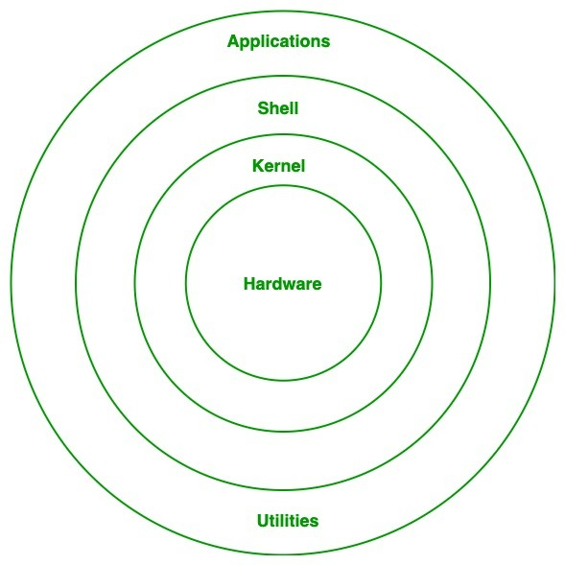
Fig 1
System Library: is a special types of files that are used to implement the functionality of the operating system.
The shell is the user interface to the kernel. It takes commands from the user and executes those commands.
The hardware Layer This consists of all the peripheral devices like RAM/ HDD/ CPU etc.
System Utility's provides the functionalities of the operating system to the user.

The Kernel is just one part of the total operating systems many parts. A fully functioning Linux system would
included the following:
Bootloader –The software that manages the boot process of the computer. This is the splash screen that most
users see on turning on their computer.
Init system –This is a sub-system that bootstraps the user space and is charged with controlling daemons.
One of the most widely used init systems is systemd..
Daemons –These are background services (printing, sound, scheduling, etc.) that either start up during boot or
after you log into the desktop.
Graphical server –This is the sub-system that displays the graphics. It is commonly referred to as the X server.
Desktop environment – This is the piece that the users actually interact with. Each desktop environment
includes built-in applications (such as file managers, configuration tools, web browsers, and games).
Applications –Just like Windows and macOS, Linux offers thousands of high-quality software titles that can
be easily found and installed.
Putting it all together in fig 2:
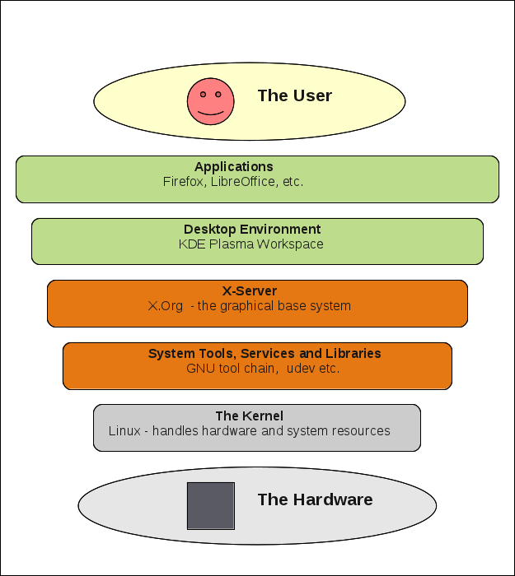
Fig 2

The Linux file system is another imported part of Linux. It is the layer that is under the operating system that
handles the positioning of your data on the storage disk(HDD). The Linux file system is based on ext4 and is
made up of many different directories. A list is showed below.
/ This is the root of the file system.
/bin: Where Linux core commands reside.
/boot: Where boot loader and boot files are located.
/dev: Where all physical drives are mounted like USBs DVDs.

/etc: Contains configurations for the installed packages.

/home: This where user will have a personal folder to put their folders and files.

/lib: Where the libraries of the installed packages located.

/media: Here are the external devices like DVDs and USB sticks that are mounted.

/mnt: Where you mount other things Network locations, USB or DVD.

/opt: Some optional packages are located here and managed by the package manager.

/proc: Because everything on Linux is a file, this folder is for processes running on the system.

/root: The home folder for the root user.

/sbin: Like /bin, but binaries here are for root user only.

/tmp: Contains the temporary files.

/usr: Where the utilities and files shared between users.

/var: Contains system logs and other variable data.

The Linux boot process can be broken down into 6 steps:
- BIOS. BIOS stands for Basic Input/Output System.
This is the hardware portion of the boot process and is the same for any operating system on a PC
- MBR. MBR stands for Master Boot Record
After step one BIOS searches for an attached disk for a boot record in the MBR once it finds it
BIOS will loaded into memory and then starts the execution of the boot record
- GRUB. GRUB stands for Grand Unified Bootloader
The primary function of GRUB is to get the Linux kernel loaded into memory and running

4. Kernel. Mounts the root file system.
Systemd mounts the filesystems as defined by/etc/fstab, including any swap files or partitions.
Keep in mind that systemd is the process responsible for bringing the Linux host up to a state in
which productive work can be done
5. Init
At this point, systemd uses its configuration file located in, /etc/systemd/system/default.target, to
determine which state it should boot the host into (runlevel).
6. Runlevel programs
Linux had six run levels that a user can boot into that can be seen in figure 3.

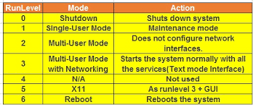
Fig 3
Linux was originally developed for personal computers based on the Intel x86 architecture, but has since been
ported to more platforms than any other operating system and the largest installed base of all general-purpose
operating systems.

References:
Admin. (2017) Linux Kernel Tutorial for Beginners Available from: https://linuxhint.com/linux-kernel-tutorial-beginners/ [Accessed 20 Oct 2020].

Plesky E.. (2019) . What Is Linux? An In-Depth Introduction Available from: https://www.plesk.com/blog/various/what-is-linux/ [Accessed 21 Oct 2020].

